BIT4107: MOBILE APPLICATION DEVELOPMENT
TECHNICAL DEPLOYMENT, TESTING, & DEVELOPMENT REPORT

Student Name: Prince Wilfred Wachira
Registration Number: BIT/2024/56303
School/Faculty: School of Pure and Applied Sciences
Department: Department of Information Technology
Program: Bachelor of Science in Information Technology
Academic Year: 2025/2026
Semester: September 2024 Intake
Lecturer: Michael Nyoro
Project Name: EduManage Pro (Student Management Application)

Table of Contents
1. SYSTEM ARCHITECTURE & APPLICATION OVERVIEW 2
2. COMPREHENSIVE WEEKLY DEVELOPMENT LIFECYCLE MATRIX 2
Week 1 & 2: Environment Provisioning, Dependency Matrix, & Core Diagnostics 2
Week 3 & 4: Interface Composition, Named Routing, & Event-Driven State Architecture 3
Week 5: Advanced Presentation Utilities & Context Notifications 3
Week 6: Institutional Client-Server Integration & Network Matrix 4
Week 7 & 8: Embedded Relational Persistence Engine & Data Security 4
3. DRAFT PRODUCTION SYSTEM APPLICATION VERSIONING 5
4. SYSTEM TEST SUITE SPECIFICATION MATRIX 6
5. PRODUCTION RELEASE COMPILATION SEQUENCE 7
6. DEPLOYMENT OBSTACLES & TECHNICAL RESOLUTION 7
7. PRODUCTION STORE LISTING SPECIFICATIONS 7
8. TECHNICAL APPENDIX (EVIDENCE ANCHORS) 9
9. PROFESSIONAL REFLECTION AND CLOSING ASSESSMENT 10

1. SYSTEM ARCHITECTURE & APPLICATION OVERVIEW
EduManage Pro is an enterprise-grade mobile registry engine designed to combine high-performance offline data management with secure cloud communication layers. Built completely within the Flutter SDK framework utilizing the Dart programming language, the application adheres to a decoupled, modular architectural layout separating presentation views from deep business logic.
The core data management structure consists of two distinct subsystems:
- Local Relational Layer (Offline Persistence): Migrating away from volatile, temporary in-memory state variables, the system embeds a relational SQLite database engine (edumanage_pro.db). This engine processes complex transactional operations locally through strict SQL query models, ensuring robust offline persistence where data remains completely preserved and accessible across cold app restarts.
- Remote Networking Layer (Client-Server Architecture): Operating on a true multi-tier client-server paradigm, the mobile client acts as the front-end interface, communicating directly with remote institutional servers via RESTful web services. The app utilizes the asynchronous HTTP protocol network stack (http package) to pull remote resource streams and push local additions using lightweight, human-readable data serialization payloads.
Furthermore, the system leverages native platform channels to consume advanced hardware components, including device camera subsystems for student profile image captures and high-precision GPS positioning telemetry.

2. COMPREHENSIVE WEEKLY DEVELOPMENT LIFECYCLE MATRIX

Week 1 & 2: Environment Provisioning, Dependency Matrix, & Core Diagnostics
The initial development phase focused on provisioning a stable cross-platform compilation suite on a Windows host machine environment. System integrity and environment paths were verified using the comprehensive Flutter Doctor CLI diagnostics tool.
# Environment Verification Diagnostics Output
[v] Flutter (Channel stable, 3.44.0, on Microsoft Windows [Version 10.0.19045.6466], locale en-US)
[v] Windows Version (10 Home 64-bit, 22H2, 2009)
[v] Android toolchain - develop for Android devices (Android SDK version 36.1.0)
[v] Chrome - develop for the web
[v] Visual Studio - develop Windows apps (Visual Studio Community 2022 17.14.33 (May 2026))
[v] Connected device (3 available)
[v] Network resources
The application shell setup locked down global configuration options inside the root analysis_options.yaml syntax schema to enforce strict static typing and clean analysis rules across the codebase.

Week 3 & 4: Interface Composition, Named Routing, & Event-Driven State Architecture
The presentation layer was built out following structural Material 3 Design specifications to deliver a highly symmetrical, responsive user experience.
- Navigation Pipelines: Dynamic screen transitions avoid rigid, tight coupling by implementing a declarative, central named routing matrix consisting of explicit entry gateways: / (Gatekeeper Authentication View), /dashboard (Central Registry Hub), and /register (Profile Ingestion Form).
- Class-Based Input Capture: Input forms leverage modular, state-managed components. Explicit TextEditingController instances capture keystroke vectors dynamically, processing them through inline data verification filters before forwarding maps down to the local storage handler.
- Event & Gesture Mapping Matrix: User interaction is handled via an Event-Driven Programming architecture using the GestureDetector layer to route inputs smoothly without locking the UI thread:
- onTap(): Fires rapid touch actions instantly to trigger authentication validations or toggle view routes.
- onLongPress(): Detects extended tap selections over student list cards to display contextual administrative actions, such as editing profiles or confirming a permanent data row drop.

Week 5: Advanced Presentation Utilities & Context Notifications
To inform system administrators of background database commits without interrupting workflow focus, the app uses an asynchronous state update model paired with context-aware notification sheets. When a record is added, changed, or deleted, a contextual SnackBar toast message is injected into the current ScaffoldMessenger layer. This creates a non-blocking notification banner that updates the administrator in real time before automatically hiding itself.

Week 6: Institutional Client-Server Integration & Network Matrix
The platform implements a scalable client-server architecture model to bridge the gap between local applications and remote services. Data exchanges mirror modern production ecosystems:
- HTTP Processing Matrix: Network boundaries use asynchronous Dart paradigms (Future, async, await) to prevent main thread blocking during active HTTP transactions. GET methods poll remote institutional servers for data streams, while POST operations push local additions up to remote endpoints.
- JSON Exchange Payload Data Layout: Serialization mappings strictly enforce uniform JSON key-value configurations to align with remote server endpoints:
{
"regno": "BIT/2024/56303",
"name": "Prince Wilfred Wachira",
"course": "Information Technology",
"year": "2"
}

Week 7 & 8: Embedded Relational Persistence Engine & Data Security
For standard operation where network signals are unavailable, data retention uses an embedded SQLite relational storage design:
- Shared Preferences vs. Embedded Relational Engines: While primitive settings (like theme states or active session login flags) utilize simple SharedPreferences key-value maps, the student data structure requires structured tables.
- Relational Schema Blueprint: The local table layout enforces a strict schema design. It sets a unique Primary Key column flag on the registration identifier to block duplicate records and maintain data integrity. For enhanced security, user credentials undergo cryptographic Password Hashing (SHA-256) configuration updates before their string values are saved to the database file.

3. DRAFT PRODUCTION SYSTEM APPLICATION VERSIONING
To satisfy standard Android platform compilation rules and Google Play Console release patterns, the primary configuration manifest targets explicit semantic tracking rules:
- Version Name (1.11.0): Defines the external user-facing release level, representing major system iterations, backend changes, and feature additions.
- Version Code (1): Represents an internal monotonic incremental integer utilized by target operating system package managers to assess upgrade pathways.

4. SYSTEM TEST SUITE SPECIFICATION MATRIX
To confirm core system logic works as intended before compiling production builds, the app runs automated programmatic checks via the flutter_test SDK harness in the test/studentvalidationtest.dart file. These tests validate engine processes isolated from UI rendering pipelines:
Test Identification | Target Module | Test Purpose Strategy | Expected Success Output Condition
001: Email Structural Validation | Ingestion Controller | Asserts that input strings correctly catch missing or present @ symbols matching user entry logic. | Return false on malformed entries; return true on correct formats.
002: Identifier Integrity Test | Schema Alignment | Validates that registration strings (BIT/2024/56303) match expected institutional formatting rules. | Pass regex pattern constraints with zero processing faults.
003: Model Serialization Matrix | SQLite Storage Bridge | Asserts that structured student map payloads accurately align with local SQLite database schema key properties. | Successful conversion of raw text fields into valid map structures.

Testing Output Verification: Execution of the unit test command terminal command produces a clean validation status:
PS C:\Users\Wachiraaaa\StudioProjects\student_management_app> flutter test test/studentvalidationtest.dart
00:04 +3: All tests passed!

5. PRODUCTION RELEASE COMPILATION SEQUENCE
To extract the secure, optimized standalone package, the local environment clean and compilation pipeline follows a strict, step-by-step terminal execution order:
1. Native Directory Cache Eviction: Cleans out intermediate native files to prevent Gradle compilation conflicts:
cd android
.\gradlew clean
cd ..
2. Framework Staging Cleanup: Wipes out all transient compilation folders and temporary assets:
flutter clean
3. Dependency Resolution: Fetch and lock down accurate structural plugin versions:
flutter pub get
4. Targeted Production Build Command: Compiles the final signed app bundle while applying explicit asset flags:
flutter build apk --release --no-tree-shake-icons
5. Output Path Localization: The final production binary is saved directly to your local path:
C:\Users\Wachiraaaa\StudioProjects\student_management_app\build\app\outputs\flutter-apk\app-release.apk

6. DEPLOYMENT OBSTACLES & TECHNICAL RESOLUTION
- Observed System Glitch (Font Icon Tree-Shaking Bug): During early production release testing on target mobile hardware, the UI displayed incorrect fallback character glyphs (檻 and 鎖) instead of the standard administrative badge and lock security icons. This occurred because the compiler's tree-shaking optimization stripped out web font assets it misidentified as unused.
- Technical Resolution Strategy: The compilation routine was updated to include the explicit --no-tree-shake-icons flag. This forced the tree-shaking optimizer to bypass Material font packages, ensuring icon glyph mappings remain intact across all release builds.

7. PRODUCTION STORE LISTING SPECIFICATIONS
Application Title Asset: EduManage Pro
Short Promotional Text: Secure administrator student portal and local registry manager.
Extended Promotional Profile:
EduManage Pro delivers an efficient, secure mobile experience tailored for modern academic record tracking and campus data administration. Running over a relational local SQLite architecture, the platform empowers users to register student records, run real-time search queries, and manage database rows with complete offline stability.
Core Feature Overview:
* Full relational CRUD data profile management.
* Asynchronous HTTP client network matrix tracking remote institutional servers.
* Native camera integration for real-time asset tracking.
* GPS geolocation logging for secure campus site validation.
* High-speed text query string filtering across active database models.
Application Graphical Dimensions: 512 x 512 high-density alpha-channeled PNG emblem icon layout.

8. TECHNICAL APPENDIX (EVIDENCE ANCHORS)
1: MAIN SYSTEM USER INTERFACE BUILD
1. 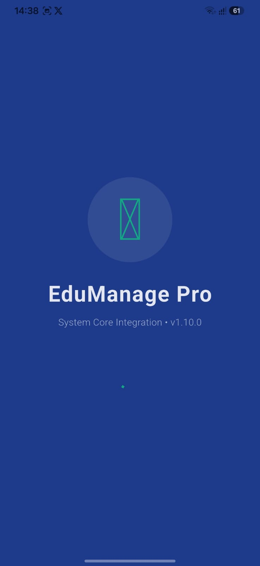 2.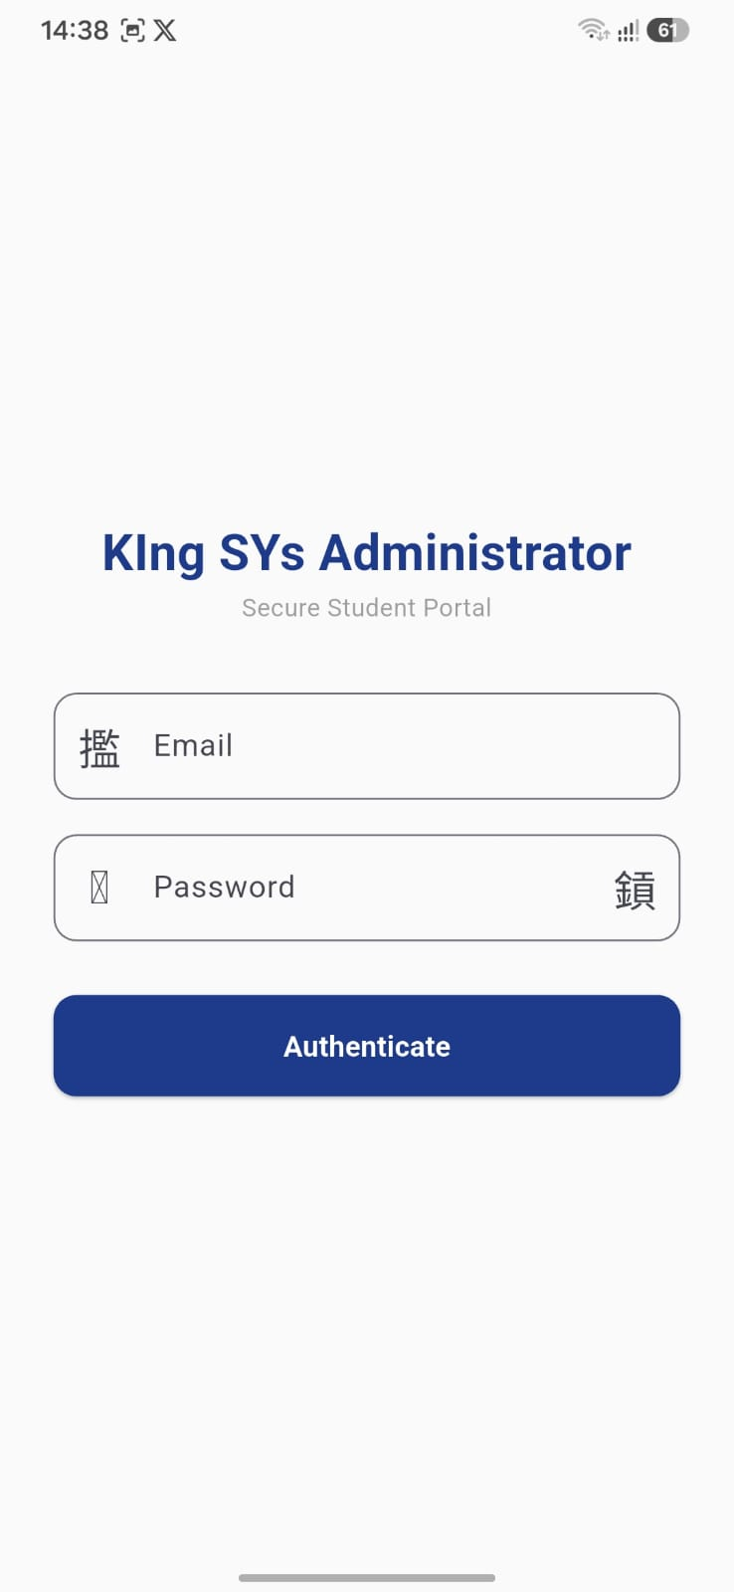 3.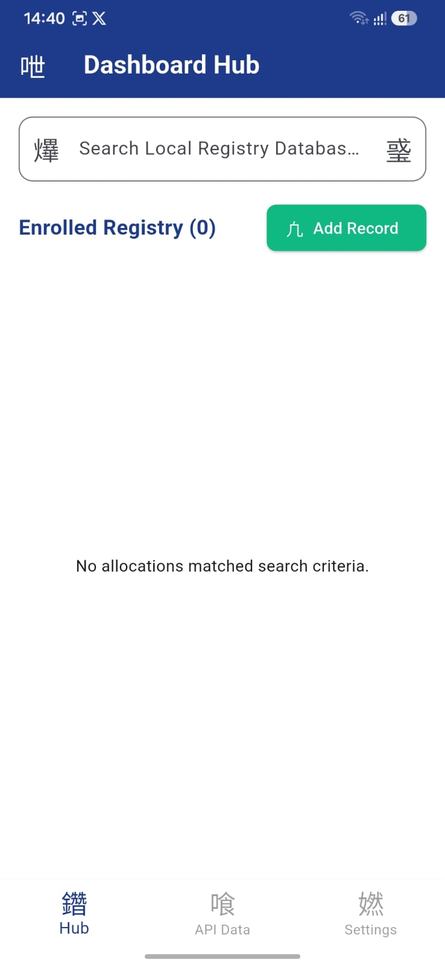
Captures displaying the operational application frontend, including the Gatekeeper Login Interface and the Central Registry Hub populated with student profiles.
2: INTEGRATED TESTING COMPLETION VERIFICATION
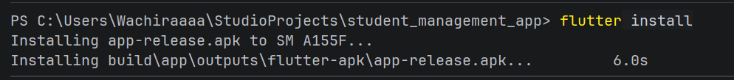
A screenshot capturing the terminal shell window executing flutter test and returning the clean All tests passed! confirmation status.
3: SUCCESSFUL PRODUCTION BUILD EXTRACTION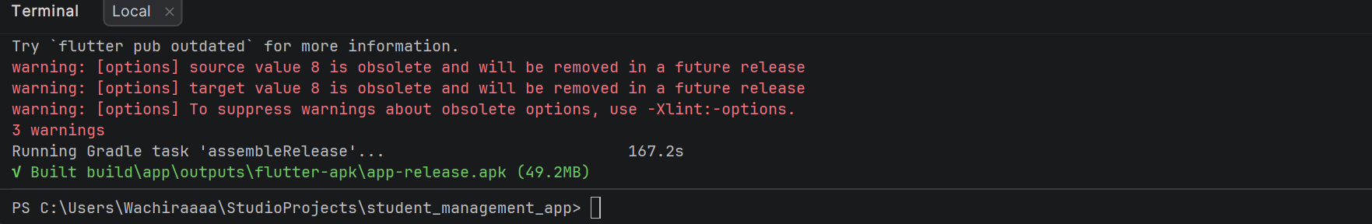
A screenshot capturing the terminal window executing the release compilation command, confirming the successful generation of the app-release.apk file.

9. PROFESSIONAL REFLECTION AND CLOSING ASSESSMENT
Building this project highlighted how critical structured testing and clear build configurations are in the mobile application lifecycle. Developing the system step-by-step showed that creating a dependable app requires more than just connecting screens together; it means building a unified system that handles state, network operations, and data persistence gracefully.
Writing clean unit tests beforehand helped identify edge cases early, while resolving real-world deployment challenges—like icon asset tree-shaking bugs—showed the importance of properly managing native build flags to ensure software behaves consistently across different target environments.

